HCALIBRATE function structure guide.

Function 'hvcalibrate' launches the calibration window called 'HVCALIBRATEWIN'. This window is the figure related to the m-file 'HVCALIBRATEWIN.m', hence modifications are to be performed on this m-file.

The file 'hvcalibrate.m' contains the help header for the function, detect if an acquisition card has been chosen and detect if window 'HVPARAMWIN' is opened. Window 'HVCALIBRATEWIN' and 'HVPARAMWIN' cannot be opened at the same time in order to avoid changing acquisition parameters while performing an acquisition. When deleting 'HVPARAMWIN', first lines of the m-file HVPARAMWIN.m are executed, so it checked if parameter structure HV exists. If not, then default parameters will be loaded.

The file 'HVCALIBRATEWIN.m' contains the callbacks and functions related to the Graphical User Interface (GUI) of the parameter window. Its organisation is as follow:

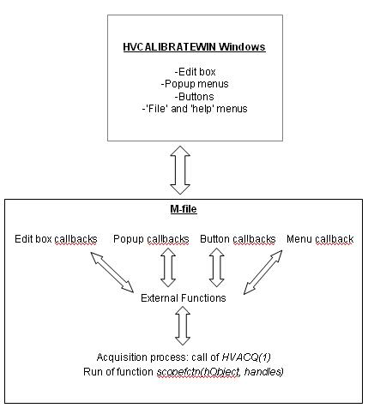

The code of 'HVCALIBRATEIN.m' is organised as the previous figure. Details of the code are given in the next pages:

BEGINNING OF CODE

% --- Executes just before HVCALIBRATEWIN is made visible.
function HVCALIBRATEWIN_OpeningFcn(hObject, eventdata, handles, varargin)

%========================================================================
%------------------------------------------------------------------------
Following code corresponds to the callback for the Cal. buttons. All
Cal. buttons have the same callback (pushbuttoncal_Callback), but they are called with a variable (a) showing the channel corresponding to the button (this is set in the property inspector in the GUI editor properties for each button. The variable a take place of eventdata, which will be use in future release of MATLAB).
%------------------------------------------------------------------------
%========================================================================

% --- Executes on button press in pushbuttoncal.
function pushbuttoncal_Callback(hObject, a, handles)

%------------------------------------------------------------------------
%========================================================================
%Following code corresponds to the callback for the radio buttons
%corresponding to the average method and other buttons, popup menus and %edit boxes.
%for the radiobuttons, a is used as an input variable to this callback with the radiobutton number. Inputs of this function are set in the property inspector window, in the 'Callback function' setting for each radiobutton.
%------------------------------------------------------------------------
%========================================================================

% --- Executes on button press in radiobutton.
function radiobutton_Callback(hObject, a, handles)

% --- Executes on button press in buttontimedown.
function buttontimedown_Callback(hObject, eventdata, handles)

% --- Executes on button press in buttontimeup.
function buttontimeup_Callback(hObject, eventdata, handles)

% --- Executes on button press in buttonrescale.
function buttonrescale_Callback(hObject, eventdata, handles)

% --- Executes on selection change in voltagepopupmenuall.
function voltagepopupmenuall_Callback(hObject, eventdata, handles)

% --- Executes on typing a range for all channels
function rangechall_Callback(hObject, eventdata, handles)

% --- Executes on selection change in popupunitall.
function popupunitall_Callback(hObject, eventdata, handles)

% --- Executes on button press in pushbuttonall.
function pushbuttonall_Callback(hObject, eventdata, handles)

% --- Executes on button press in checkboxall.
function checkboxall_Callback(hObject, eventdata, handles)

function checkbox_Callback(hObject, eventdata, handles)
%------------------------------------------------------------------------
%========================================================================
%Following function is used to list all the handles with an increment
%number. This will allow to easily use these handles in for loops in order to quickly change properties. Handles names with increment cannot be created under the GUI editor when creating an object, hence this function. Creating handles with increment names might be available in futur release of MATLAB.
Other external functions are listed here.
PS: List of units can be edited in this function
%========================================================================
%------------------------------------------------------------------------

function handles=listhandles(hObject, handles)

%Following function set the strings to show parameters for all channels.
function createlist(hObject,handles)

%Following function sets visibility of some handles in the window
function visiblehandles(hObject, handles)

%------------------------------------------------------------------------
%========================================================================
%The following functions are used as a general callback for all the edit
%boxes corresponding to the channel description, range and units. This is
%use to reduce the number of callback functions, as only this function is
%called as a callback for each edit box.
%========================================================================
%------------------------------------------------------------------------

%Callback function for the channel description edit boxes
function chnameedit_Callback(hObject, a, handles)

%Callback function for the channel range edit boxes
function rangeedit_Callback(hObject, a, handles)

%Callback function for the channel unit edit boxes
function unitch_Callback(hObject, a, handles)

%Callback function for the channel unit popup menus
function popupunit_Callback(hObject, a, handles)

%------------------------------------------------------------------------
%========================================================================
%Following code corresponds to the coding of the acquisition parameters and the creation of the analog input object.
%========================================================================
%------------------------------------------------------------------------

% --- Executes on button press in scopeon.
function scopeon_Callback(hObject, a, handles)

% this function run the scope and monitors if desired and store measured
% data in order to be used for the calibration and to plot.
function scopefctn(hObject, handles)

%------------------------------------------------------------------------
%========================================================================
%Following code corresponds to the coding of the menu and close function
%========================================================================
% -----------------------------------------------------------------------

% --- Executes on button press in buttonpara.
function buttonpara_Callback(hObject, eventdata, handles)

%function used to load parameters from a .pas file
function load_Callback(hObject, eventdata, handles)

%function used to load default parameters
function loaddefault_Callback(hObject, eventdata, handles)

%function used to save the parameters into a .pas file
function save_Callback(hObject, eventdata, handles)

function exit_Callback(hObject, eventdata, handles)

function help_Callback(hObject, eventdata, handles)
%put here a link to the help file in .pdf or .doc
%winopen('help.doc')

%function to be called when closing the window (via 'exit' or by closing
%using the top right windows buttons)
function closefcn(hObject, a, handles)

